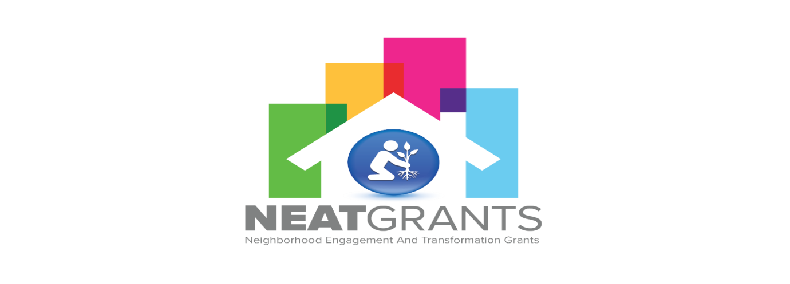
DUE DATES:

- DECEMBER 22, 2024
- FEBRUARY 22, 2025
- MAY 22, 2025
- AUGUST 22, 2025
- AUGUST 7, 2024

Neighborhood Engagement and Transformation (NEAT) Grant Program

PROJECT STATUS FORM

Contract #: ________________________________________________________________

Organization/Community:________________________________________________

Contact Person: _____________________Phone /Cell #_______________________

Project Location: ______________________________________________________
Date: ____________________________________________________

Please list tasks that are currently in progress or have been completed to date.

____________________________________________________________________________________________________________________________________________________________________________________________________________________________________________________________________________________________________________________________________________________________________________________________________________________________________

________________________________ _________________
Signature Date

________________________________ _________________
Print Date

E-mail to: cmathews@pbcgov.org

