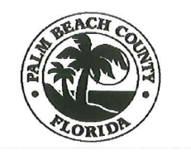

DISCLOSURE FORM

Palm Beach County

Engineering & Public Works Department

Roadway Production Division

2300 N. Jog Road

3rd Floor – Suite 3W-33

West Palm Beach, FL 33411

(561) 684-4150

|  |  |  |  |  |  |
| --- | --- | --- | --- | --- | --- |
| Date: | | | Bid Document # | | |
| CONTRACTOR PRIMARY CONTACT INFORMATION | | | | | |
| Company Name: | | | My Company is: Prime Sub-Contractor | | |
| Company Primary Address: | | | | | |
| City: | | State: | | Zip: | |
| Primary Contact: | Email: | | Phone No. ( ) | | Fax No. ( ) |

|  |  |  |  |  |  |
| --- | --- | --- | --- | --- | --- |
| Date: | | | Bid Document # | | |
| CONTRACTOR SECONDARY CONTACT INFORMATION | | | | | |
| Company Name: | | | | | |
| Secondary Address: | | | | | |
| City: | | State: | | Zip: | |
| Contact: | Email: | | Phone No. ( ) | | Fax No. ( ) |
| PLEASE FILL IN YOUR COMPANY INFORMATION AND EMAIL TO: ENG-RoadwayBids@pbcgov.org | | | | | |